## Problem: Supply & Demand

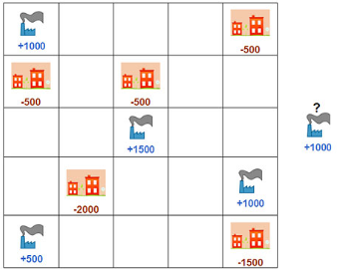

Moving resources efficiently from supplier to consumer is a challenging problem that can be solved using O.R. techniques. Figure 1 shows a map of blue factories that supply food to orange towns. The numbers below the factories and towns indicate how much food (in kg) each supplies and demands, respectively. Any factory can supply any amount of food to one or several towns. A new factory has not yet been determined. The distance between adjacent cells on the map is 1 km. The cost to transport 1 kg of food 1 km is $10. The new factory cannot occupy a cell that already contains an existing factory or town.

**Q: If the new factory is optimally located, what is the total transportation cost to satisfy the demand of all towns?**

Nomenclature:

|  |  |
| --- | --- |
| Sets: |  |
| $$N$$ | Set of nodes |
| $$L$$ | Set of branches |
| Indexes: |  |
| $$i$$ | Index of node |
| $$ij$$ | Index of branch |
| Parameters: |  |
| $$c_{i}$$ | Capacity of each factory at node $i$ |
| $$d_{i}$$ | Demand of each town at node $i$ |
| $$t_{ij}$$ | Distant from factory located at node $i$ to town located at node $j$ |
| $$p_{i}$$ | Indicate if the node $i$ is occupied or not |
| Variables: |  |
| $$x_{ij}$$ | Quantity of food transported from node $i$ to node $j$ |
| $$y_{i}$$ | Binary variable of investment at node |

|  |  |
| --- | --- |
|  |  |
|  |  |
|  |  |
|  |  |
|  |  |
|  |  |

## Problem: Choose your crew

Successfully navigating the waters during sea voyages is a challenging task. A captain’s most important decision is selecting the right crew for the voyage. A mix of different skill sets are required to sail the ship efficiently, navigate to the destination, and fish for food along the way.

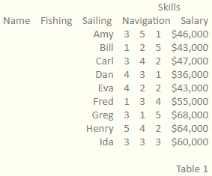

Table 1 shows a list of crew members that are available for you to hire for the voyage. Each crew member demands a salary for the voyage and has different skill levels of Fishing, Sailing, and Navigation.

In order for your journey to be successful, you must have a cumulative skill of 15 or more in each of the three skill categories from all of your chosen crew members. You may choose as many crew members as you like.

**Q: What is the minimum achievable cost for the voyage?**

Nomenclature:

|  |  |
| --- | --- |
| Sets: |  |
| $$N$$ | Set of crew members |
| Indexes: |  |
| $$i$$ | Index of crew member |
| Parameters: |  |
| $$f_{i}$$ | Fishing skill of crew member $i$ |
| $$s_{i}$$ | Sailing skill of crew member $i$ |
| $$n_{i}$$ | Navigation skill of crew member $i$ |
| $$c_{i}$$ | Salary of crew member $i$ |
| Variables: |  |
| $$x_{i}$$ | Binary variable of crew member |

|  |  |
| --- | --- |
|  |  |
|  |  |
|  |  |
|  |  |
|  |  |

## Problem: Combinations locks

Many people store their valuables in home safes because they protect against burglaries and fires. They are a good place for storing insurance documents, car titles, cash, and many other valuables.

Figure 1 shows six dials that are on the front of your home safe. In order to open the safe, you must set each of the dials to one number. When the correct numbers are selected on each dial, the safe will open. Unfortunately, you have forgotten the combination. All you can remember is that the numbers on all of the dials summed to 419.

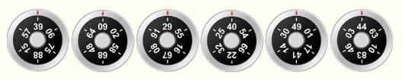

**Q: What numbers should you select in order to unlock the safe?**

Nomenclature:

|  |  |
| --- | --- |
| Sets: |  |
| $$N$$ | Set of dials |
| $$P$$ | Set of options on each dial |
| Indexes: |  |
| $$i$$ | Index of dial |
| $$p$$ | Index of options |
| Parameters: |  |
| $$n_{i,p}$$ | Option $p$ at dial $i$ |
| Variables: |  |
| $$x_{i,p}$$ | Binary variable for option $p$ at dial $i$ |
| $$α$$ | Clearance variable |

|  |  |
| --- | --- |
|  |  |
|  |  |
|  |  |